Vol. 1, Issue 06 AUGUST 2002

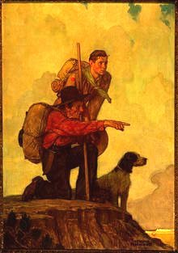
The Scouting Scope
The aim of this UNOFFICIAL, resource-based newsletter is to give Scouters of every section a more focused look at some of Scouting’s more fun and challenging tasks that Leaders and program builders face in the 21st century. The information contained in this resource is from the amalgamated file of Jeff Melvin (chief-editor and contributor). I encourage you to follow the PPP rule with this resource
(Print, Promote, and Pass-along)

You will find that the information in this newsletter will have locally “Field Tested” ideas on GAMES, SONGS, PROGRAM ACTIVITIES, STORIES, MEETING PRAYERS, GROUP CHALLENGE, AND SCOUTING QUOTES that are prepared for use in your programs. If improper credits are given to a contribution, then please feel free to contact me at scouting@canada.com. Best of luck with you’re planning on the adventure trail.

FEATURE ARTICLE

Hints for Effective
Program Planning

Although nobody can plan your program for you, since it all depends on the age, sex, and character of the people who are going to be involved in doing the activities, there are a few guidelines that you can follow to plan an effective program which is fun, interesting, (dare we say it) educational, and most importantly is going to make people want to come to your Unit meetings.

The first key word is variety. Nobody will want to come to your Unit meetings if you do the same things every week. In the Program Ideas Bank that we've compiled here, the ideas have been split into five categories: Indoor Activities, Games, Outdoor Activities, Fund-raising Activities, and Social / Recruitment Activities. Within these broad categories, the activities can be split down further. Try to ensure that you include program items from each of the four main categories when planning your program - putting a social event in once a term may take a little extra planning, but is great fun and will help to boost numbers in your Unit. As well as this, fund-raising may be a bit of a drag, but you can always try to make it fun, and remember - the more money you have in Unit funds, the more activities you can afford to do.

Key word number two is preparation. It doesn't matter how fun the program item sounds on paper, if nobody can be bothered to prepare it, it will inevitably be a failure. Make sure that you don't have the same person organizing events every week - share out the work load. If somebody is especially interested in a particular subject (e.g. pottery), ask them to organize an evening based around that subject. If the Program Item is a large one (for example a social), ask two or three people to work together to organize it - for our annual Christmas Camp last year we formed a small committee to organize it, and it worked brilliantly (it keeps the leaders happy too - they don't have to do as much)! Remember: to fail to prepare is to prepare to fail.

The third key word is budgeting. There are two ways to look at this. Firstly, if you have too many expensive activities and you ask individual members to pay for themselves, they'll stop coming. Secondly, if you have too many expensive activities paid for by Unit funds, those funds start to disappear very rapidly. So find a happy medium - when you do an activity that requires an extra cost, ask Unit members to pay some of the cost (for example half), and subsidize the activity with funds from the Unit. The second solution is to make sure that you don't do too many activities which cost extra - Scouting should be for everybody, not just those who can afford it. If you do a lot of expensive activities, make sure you plan enough fund-raising events to cover the costs. Not only can these events be good fun, but they bring in much needed funds for the Unit.

Fourthly, remember to make your program interesting. Different peoples ideas of what is interesting and what isn't vary immensely, but you can be sure that if you spend too many Unit meetings train spotting, people will stop coming. The best way to ensure that your Program appeals to everyone (and not just the Executive Committee) is to make sure that everybody has an input to it. Before Executive Committee meetings, ask Unit members to make suggestions about what they want to do at their meetings. Once you know what people want to do, you can start to effectively plan a program. Try also to get everyone involved in organizing events - if somebody suggests an activity, why not ask them if they wouldn't mind organizing it. People are much happier organizing events they enjoy doing, and as a result everybody else will have a better time as well!

Finally, make sure your program is innovating. Too many Units seem to think they can recycle the same program year after year. This doesn't work! As old people leave and new people join the Unit they will have different interests - move with the times, and make sure you have something in the Unit program that appeals to everybody, not just those who have been there the longest. Don't be afraid to try something new. If it works, well done (and don't forget to tell us about it)! If it doesn't, never mind - you can learn from what went wrong, and fix the problems for the next time.
Pyramid Program Planning

Article taken from Scouting Magazine <http://www.enterprise.net/scoutingmagazine/>
[April 1999: Volume 93: No. 4], written by Audrey Milan (content edited by website editor). Useful to think about when planning a Program for any Section in the Group.

"What are we going to do tonight Akela?"

It's great to hear that excitement when the Cub Scouts greet you as you arrive for a Pack meeting. But if you are asking yourself that same question then there is probably a feeling of panic in the pit of your stomach. The same goes for the start of a Troop, Colony, or Unit meeting, of course. Program planning makes the difference between sending members home still excited and hardly able to wait for next week, or bored, disillusioned and wondering whether it is worth coming back.

Program planning is so crucial to achieving good Scouting that Sectional Assistant District Commissioners need to be ready to give a hand to any Leaders who find it difficult. One approach is to start with the simple overview called Pyramid Program Planning (PPP). Let's start by looking at how this can be used to help you plan your own program.

Start at the top of the pyramid with the long term planning - you will probably know the highlights of the District's year well in advance. Events such as St. Georges Day Parade, District Competitions or a visit of the Chief Scout to your County all give a start to your plan.

In the middle section, the medium term - Executive meetings and various Committee meetings will take up some time each month and all need to be planned into the program. Many of these dates are largely determined by others. Also in this section go Group events (those which you already have a date for), such as the AGM, Scout's Owns, Group camps and things such as this.

The final level is for planning your individual Section meetings - these aren't just those that take place on the night you usually meet, but also any weekend activities, camps, etc. The further in advance you decide these dates, the more likely people are to be able to come. This final level in the pyramid is the level at which the game of Scouting is won or lost, where young people experience Scouting at its best, and make it their lifestyle, or find it boring and leave. You can make a difference.

Unknown author
" I don't dream about actors and actresses; They dream about me. I am reality, they are not."
--- Alexander Popov ---

Games for Your Meeting

TRASH BALL
Divide the group in half and situate them on opposite sides of a volleyball net (or rope strung between two trees or chairs). Offer each group an equal amount of dry trash, such as newspaper, aluminum cans, 2-liter plastic bottles, small cardboard boxes, cleaned-out milk cartons, etc. On “GO”, each team tries to put their trash over the net. Do not set a time limit for the game, but tell them you will signal when the game is over. This unexpected signal prevents a team from collecting all the trash and throwing it over seconds before the time limit. The winner is the team with the least amount of trash on their side of the net at the end of the time limit.

ONE, TWO, THREE
Two youth sit facing each other about 6 feet apart. One youth holds three small pebbles behind his back. When the pebble holder decides how many pebbles he will use, he brings a clenched hand from behind his back with one to three pebbles in it. The guesser touches or points to the hand and states the number of pebbles he thinks it holds. The hand is instantly opened to show whether the guesser is right or wrong. If the guesser is right, he does the pebble hiding. If the guess is wrong, the opponent continues until the guesser is right.

FIRE
Two parallel chalk lines are drawn about 30 yards apart, the two teams forming on these lines facing each other. The idea is to throw a tennis ball, indoor baseball or basketball at the opponents. If a Scout is hit he is out of the game. If he catches the ball. However. the thrower is out. The Scouts throw in turn. each team alternating, beginning with the tallest Scout of each team, who is the captain of that team. It is the duty of this captain to shout "Fire!" This is the signal for his team to dodge as far back of the line as they wish, and for the other team to throw the ball. After each throw the team that has been dodging re-forms on the line. No one may throw or dodge before the captain shouts "Fire!" The best distance varies greatly with the sort of ball used.

INDOOR DUCK ON A ROCK
This is played with cheap ($1) baseballs or tennis balls. One is placed in a small chalk or taped circle by the Scout who is "It." The others roll the balls and try to knock it out. If they succeed, the "duck is off" and the ball must be replaced before the players can be tagged on their way back with their ducks to the line. Or an Indian club can be knocked over by balls or beanbags.

LEG WRESTLING
This is a trial of skill between two Scouts. They lie on their backs side by side with elbows locked and heads pointing in opposite directions. Together they count three. On the first and second count they bring each inside leg up to a vertical position. On the third count they vigorously lock legs and attempt to roll the other fellow up onto his shoulders and thence completely over. It isn't always the heaviest Scout that wins.

PASS AND TOUCH GAME
Players form a circle facing inward, with their hands behind their backs. They pass a series of nature objects (leaf, stone, twig, shell, feather, pine cone, etc.) from hand to hand around the circle. Each boy tries silently to identify the object by feel. After several items have been passed, see who can say (or write) the most items correctly.

Together Everyone Achieves More!

Program Ideas and Hints

Have each Cub trace their hand on a piece of construction paper. Ask the partners to cut them out. On the palm, write the Cub’s name. On the thumb, write the Cub’s birth date; on the first finger, write a favourite hobby; on the second finger, write his favourite color; on the third finger, write the name of his pet; on the fourth finger, write their favourite sport, book or place to visit. Let the Cub do as much of the writing as possible. Use a pin (safety pin is more reassuring) to turn it into a nametag.

Can You Build It?
You'll need a couple sets of plans, and some Lego’s or blocks. Divide the youth into two groups (or even pairs if you have enough materials). Half are engineers and half are builders. The engineers have to explain the instructions to the builders to get the project done. The catch is: the engineers can't touch the Legos and the builders can't see the plans. To make it more challenging, the builders must ask the engineers only yes/no questions.

Thing-A-Ma-Jig
You'll need a couple piles of scrap materials like toothpicks, straws, index cards, tacks, lids, film canisters, wood pieces, cardboard, string, etc. Divide the boys into two teams. Be sure each player gets a few "things" to help build the Thing-A-Ma-Jig. On signal, a player uses one of the items to start the Thing-A-Ma-Jig. In turn, each player adds an item until all items are used. They are done when they can name the Thing-A-Ma-Jig and tell what it is (or does).

Experiment #1!
Materials: Rubber balloon, several straight pins, plastic tape

Inflate the balloon and affix little squares of tape to it. Stick each pin through the center of the tape pieces. Now pull them out. The balloon doesn't burst either time!
Why: The adhesive substance on the tape acts like a self-sealing tire, adhering to the pin as it is pressed inward. When the pin is removed, the adhesive is forced outward by the air pressure from the balloon, automatically sealing the tiny pinholes.

Bee Puppet
Put pom-poms on a yellow sock as the eyes. A pipe cleaner serves as the antennae. Then you paint black stripes.

Popsicle Puppets
Take a popsicle stick and paint the eyes, nose and mouth. Use lace to make the dress and wool yarn for the hair.

More Popsicle Puppets
Draw any kind of character you want - a dog, cat, person or anything. Cut it out and color it; then glue it to a popsicle stick!! You can also make a family and friends for your puppet!

Cereal Box Puppets
Cut one side of a SMALL cereal box in half (width) and fold the box towards the uncut side. This forms the mouth; your fingers fit into the top jaw; your thumb fits into the lower jaw. Add eyes, lips, and hair. Drape a scarf over your arm for clothes.
Songs & Yells

Big Thumb: Hold out a hand at arms length, make a fist with the

Drum: On legs make a rat-a-tat sound 3 or 4 times, then hit the stomach two times and say "Boom, Boom".

Eskimo Cheer: Brrrrr-rrr, Brrrrr-rrr.

Farewell: Hold one hand above the eyes as though looking into the distance while slowly waving the other hand.

Fireman Yell: Water, Water, Water! More, More, More !

Fish: Pretend to a fish by it's tail with one hand with one hand and plug your nose with the other and say: "PEEE-U-EEEEE!!!!" Variation 2: Suck in your cheeks, form an "O" with your mouth, move it as if you were a fish, without making a sound!!! Variation 3: Hold your nose and say: "SMELLY, SMELLY, SMELLY!!!
Fisherman: Pretend to reel out some line, let it drift, yank your pretend pole back and start to reel in the fish. Struggle with it for a short time and say: "I'VE GOT IT!!! I'VE GOT IT!!!"

Our Paddles Keen and Bright

Our paddles keen and bright, flashing like silver,
Swift as the wild goose flies, dip, dip, and swing.
Dip, dip, and swing them back, flashing like silver,
Swift as the wild goose flies, dip, dip, and swing.
Sing two or three times through, with voices becoming louder and then softer-as though canoes were first approaching and then moving away. [Also may be sung as a round.]

" Blessed is he who has learned
To admire but not envy,
To follow but not imitate,
To praise but not flatter,
And to lead but not manipulate."
-- W.A.Ward --

Camp School Banana Song
Sung to tune "Ging Gang Gooley"

We're a bunch of yellow bananas, we're a bunch, we're a bunch.
We're a bunch of yellow bananas, we're a bunch, we're a bunch.
Appealing, yes we're appealing, we've got the feeling
That we're a bunch of Scouts.
Appealing, yes we're appealing, we've go the feeling,
That we're a -{spoken}- Bunch of Scouts!
Quartermaster's Store
There are rats, rats, as big as alley cats,
At the store, at the store.
There are rats, rats, as big as alley cats,
At the Quartermaster's store.
Chorus:
My eyes are dim, I can not see.
I have not brought my specks with me. [Repeat.]
Mice . . . running through the rice.
Snakes . . . as big as garden rakes.
Gravy . . . enough to float the navy.
Cakes . . . that give us tummy aches.
Eggs . . . with scaly chicken legs.
Cheese . . . that makes you want to sneeze.
Scouts . . . eating brussel sprouts.
Leaders . . . slapping at the skeeters.

Scouters’ 5 (meeting stories)
Submitted by Matt Poirier

Sleeping Well
In Israel, there are two major bodies of water. The waters of the River Jordan feed both of these bodies of water. One is the Sea of Galilee, which is full of fish, and is surrounded by lush vegetation and trees. It is a living body in every sense. The other is the Dead Sea. There is nothing green there, there are no fish, and the sea is stagnant and dead. The difference is that the Sea of Galilee overflows, for every gallon of water that flows into the sea, a gallon given up and is passed on downstream. It is constantly renewing itself; it gives as much as it takes. The Dead Sea, on the other hand, because of its geography, only takes. It gives up nothing. The water there is never cleansed it stagnates and dies. And everything depending on it dies also. Some people say that there are two kinds of people in the world -- those that constantly give of themselves (who help other people at all times), and those that only take.
So remember: Those that only take Eat Well. But those who give sleep Well.

Consider the flashlight
Equipment needed: Flashlight, a paper grocery bag and darkness.

Consider the flashlight. Think how useful it is as we find our way along the trail at night or prepare to bed down in our tents. Consider the batteries in our flashlight. If we keep them too long or use them too much eventually they loose their power and our light dims beyond usefulness. Consider that if we have only one flashlight for a group of people, only the one person holding the light determines what we will see or what direction we will proceed. If we have many lights, we have many possibilities and choices to make. Also notice that if everyone holds his light high at the same time, the light fills an area larger than if everyone holds their light low. Notice how the group benefits from the light held high. Consider what happens if we put our light inside a paper bag and turn it on. We can see what is inside the bag very well but can not see things outside the bag well at all because the bag cuts the light. Sometimes it is important to see inside the bag. Sometimes it is important to see outside the bag. The flashlight is like us, like people. We are most useful and helpful to others when we are outside the bag and in groups. The batteries are like our beliefs and our ideas. Sometimes they need recharging or replacing in order for the light to remain useful. The bag represents some of the choices we make about sharing our selves with others.

How will you hold your light? How long will your batteries last? How many bags do you bring along and is there anything worth finding inside? Consider the flashlight.

The Traveller and the Tracker...
Once a Traveller and a Tracker set out to explore the world together. As they wound their way through the wilderness, the Traveller was amazed at the Tracker's habit of pausing several times a day to pray.
"Why do you pray to something intangible?" the Traveller asked. "How do you know there is a God?"
Now the Tracker was very skilled in noticing things and, through the years, had gained much insight reading the smallest signs. And he answered the Traveller this way:
"I know there is a God when I see the leaves turning yellow. I know there is a God when a trout jumps at a fly, and when grass waves in the dry wind. I know there is a God when clouds shade my head and the stars wink at night."
"So you see," said the Tracker, "I know there is a God, for I can see his footprints throughout the Universe."

One Day At A Time
A friend of ours was walking down a deserted Mexican beach at sunset. As he walked along, he began to see another man in the distance. As he grew nearer, he noticed that the local native kept leaning down, picking something up and throwing it out into the water. Time and again he kept hurling things out into the ocean.
As our friend approached even closer, he noticed that the man was picking up starfish that had been washed up on the beach and, one at a time, he was throwing them back into the water.
Our friend was puzzled. He approached the man and said, "Good evening, friend. I was wondering what you are doing."
"I'm throwing these starfish back into the ocean. You see, it's low tide right now and all of these starfish have been washed up onto the shore. If I don't throw them back into the sea, they'll die up here from lack of oxygen."
"I understand," my friend replied, "but there must be thousands of starfish on this beach. You can't possibly get to all of them. There are simply too many. And don't you realize this is probably happening on hundreds of beaches all up and down this coast. Can't you see that you can't possibly make a difference?"
The local native smiled, bent down and picked up yet another starfish, and as he threw it back into the sea, he replied, "Made a difference to that one!"
SKITS (walk ons)

News Flash…
A small two-seater Cessna 152 plane crashed into a cemetery early this afternoon in central Slobovia. Slobovian search and rescue workers have recovered 300 bodies so far and expect that number to climb as digging continues into the evening.

2. 1st person: "Excuse me, but is that the sun or the moon?"
2nd person: "I don't know. I'm new to these parts too."

3. A boy is sitting on the lake with a fishing pole in hand. There is a NO FISHING sign nearby. The game warden appears.
Fisherman: Are you the game warden.
Game warden: Yep!
Fisherman: Just teaching him how to swim (pointing to the worm on the pole)

4. (Boy runs on interrupting leader): "We interrupt this program for an important news flash." Turns flashlight on and off, shining it in the
audience's eyes. (Most effective at a campfire)

TEAMWORK means that we share a common ideal and embrace a common goal. Regardless of our differences, we strive shoulder to shoulder, confident in one another’s faith, trust and commitment. In the end, teamwork can be summed up in five words…
“WE BELIEVE IN EACH OTHER.”

-- Successories --

5. First Scout: I bet I can jump higher then a house.
Second Scout: I bet you can't.
First Scout: Yes I can. Did you ever see a house jump.

6. Someone walks on pulling a rope. The leader asks "What are you pulling that rope for?"
He answers, "Did you ever try to push one?"

7. Scout 1:(running on stage) "They're after me!"
Scout 2: "Who's after you."
Scout 1: "The squirrels! They think I'm nuts!"

8. Fortune Teller: "That will be $20 for two questions."
Client: "Isn't that a lot of money for two questions?"
Fortune Teller: "Yes, it is. Now what is your second question?"

9. The Announcement
Campfire chief and a volunteer in the audience
Campfire Chief: And now it's time to make a spot announcement.
(Dog barks from the audience.) Thank you Spot.

10. Two boys playing quick draw:
1st boy: "My Scoutmaster (Cubmaster etc.) can shoot a gun faster than any man in theWest."
2nd boy: "Really?" What do they call your Scoutmaster."
1st boy: "Toeless Joe."

11. 1st boy: "I heard you had an accident on your hike today."
2nd boy: "No but I did get bitten by a rattlesnake."
1st boy: "You don't call that an accident."
2nd boy: "Heck no, he did that on purpose."

12. Big Chief: Bring in 10 scalps, kill 5 buffalo bare handed and go into desert without water for a moon. Then I will pronounce you Big Brave. You understand?
Indian Brave: Yes. What do I do to get pronounced Little Brave.

13. The three boys are in a line facing the audience.
Second Boy in Line: This story begins with "Once upon a time"
First Boy: Hey, wait a minute, I'm the beginning.
Middle Boy: I'm the middle.
Last Boy: That's nothing I'm the end.

14. 1st Scout: I went fishing last week.
2nd Scout: What did you catch?
1st Scout: Three bass and one smelt.
2nd Scout: It did? Which one?

15. Two guys talking, first asks the second where he is going; second says fishing. First scout asks second scout what he has in his mouth and the first says worms. The first guy says good luck and slaps second guy on the back.

16. First scout walks to center of stage, stands to attention, salutes and says, "BE PREPARED." This is repeated by three other scouts. When they are all standing side by side, a loud motor horn or explosion is let off behind the audience.
The scouts then all say, 'WE TOLD YOU TO BE PREPARED'

TID-BITS…

FOLLOWING MUSICAL DIRECTION
Test your ability to follow musical direction.
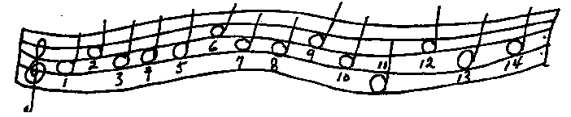
1. If you ever saw the cat that fiddled while the cow jumped over the moon, write C in notes 4 and 7. If not, write M in notes 1 and 11.
2. If Ti comes before La in the musical scaled, write T in note 7. If it comes after La, write L in note 7.
3. If a clarinet is a musical instrument write a C in note 5. If not, write I in note 2.
4, If the musical scale has 8 notes in it write H in note 8, if not, write S in note 4.
5. If ukuleles and banjos are both stringed Instruments, write a U in note 2, but if they are not, don’t write anything.
6. If CISUM is music spelled backwards, then write Y in note 14. If not, write N in note 3.
7. If the word note starts with N then write that letter in note 13.
8. If the word accordion contains the word cord, write an A in notes 9 and 6. If not, write the letter N in those two notes.
9. If Beethoven was a famous ball player, write B in note three, If not, write an S in note 3.
10. If you can play a musical instrument, write an I in note 4. If you can’t we’ll let you put one there anyhow.
11. If Rock and Roll Is a kind of music, write R in note 10, if not, call your favorite disc jockey and ask him what it is.
12. If you like music, you’re on the right track, go on to the next one.
13. If you think this game Is over now write 0 in note 12, and you are right because you can now read the message in the musical notes. If you followed directions correctly, you will have this in your notes.
14. If you are superstitious you better read this last instruction so you didn’t end on instruction #13. This instruction is to pat yourself on the back for the fine job you did in following instructions. You’ve passed the test to join the MERRY MUSIC MAKING MOB (THE PUBLIC).

Crazy Relays to Try
1. Run to the other end, eat one cracker, then whistle/hum "Twinkle, Twinkle, Little Star."
2. Go down and back tapping a balloon and keeping it in the air. If it hits the floor, pick it up and continue.
3. Walk down and back with a potato between your knees. If it falls, pick it up and put it back between your knees and continue.
4. Trot backwards, flapping your arms.
5. Using a broom, sweep a paper towel tube down and back.
6. Place an empty paper cup over a straw and place the straw in your mouth. Go down and back keeping the cup on the straw and the straw in your mouth.
7. Clasp your ankles with your hands and keeping them there, go down and back.
8. Carry a craft stick/clothespin/small straw to the other end and drop it into a jar/can.
9. Place a ping pong ball on a spoon and carry it down and back.
10. Using a long cardboard tube (gift paper tube), "sweep" an empty pop bottle or can down and back.
11. Carry "n" stacked checkers in your open hand (can't close fingers around them) down and back. Can use two hands to pass the checkers to the next player. You can't start running until the checkers are stacked in your hand
12. Carry an empty pop can down to the other end and stack them up into a tall tower. If the tower falls, re-stack it before returning.

RECIPIES for Those
Who Eat…

Twists / Green Stick Cooking / Kebabs
The simplist form of this is to simply 'twist' some doe around a green sapling branch. And roast the doe over the fire.
You could try some variations on a twist mixture ... e.g. sugar and cinnamon in the dough should be quite tasty. I've never tried it myself (just thought of the idea ) but I will next camp.

Talking about twists, one of my Cubs has his with a few drops of ... Tabasco sauce !Kebabs are good - I buy the bamboo skewers. You can put all sorts of stuff on them. Steak, onions, peach, potato and kiwi fruit is not bad and it will get the kids' attention.
Best wishes,
Ian Ford
AGSL 25th Greenwich Scout Group
Boy Scout trainer, Channel District BSA
London UK

An Egg in an Orange
Cooking an egg in an orange. This one is easy. Give everyone an egg and an orange. Cut of the top of the orange. Empty the orange with a spoon so that the egg can be placed in the empty shell. Put back the part of the orange you cut off and place it in a (small) fire. The egg will be boiled in the juice off the orange!
Edwin van der Elst
Prinses Irene Groep 45, Rotterdam

The Making of a Challenging Program
• It must have strong appeal for youth
• It should offer variety so each youth can do the things they like.
• It should instil the deeper values of Scouting.
• It has to be FUN.
• It should contribute toward the development and maintenance of strong family relationships.
• It should be simple, within the capability and interests of both Scouting Members and Parents.

" Don't let your problems get you down. Pick them up and turn them around."

Back to the Basics

Bring back one of true Scouting skills…lashing and rope work. Give these simple projects a try with your troop or company and send us a copy of it for publication!
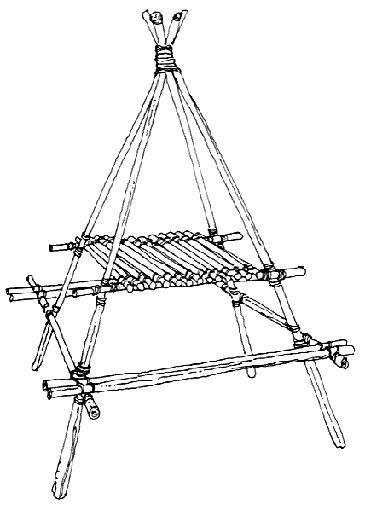

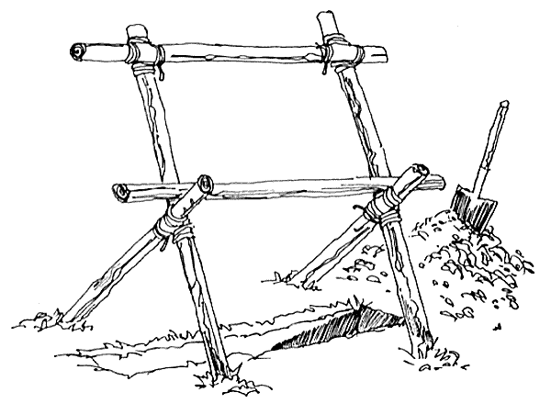

Meeting Prayers
(Universal & Generic)

-Submission by Martin Drapeau-

Lord, Thank you for bringing us together in the Family of Scouting
Bless our Group and all its Members
Help us to be loyal to our Promise, to each other, and to ourselves
And in everything that we do, help us to put other people first.
By Owen Sayers

Lord, Thank you for bringing us together in the Family of Scouting
Bless our Group and all its Members
Help us to be loyal to our Promise, to each other, and to ourselves
And in everything that we do, help us to put other people first.
Forwarded by Owen Sayers

Dear God, help us to carry your spirit in our lives, that we may share it with others by living it ourselves.
Help us to offer all that we have and are in your service.
And help us to live the spirit of Scouting so the spirit will live on through us.
From "A Memorial to a Scouter". by Laird Vanni

I'd Rather Be
I'd rather be a "Could Be"
If I couldn't be an "Are"
For a "Could Be" is a "May Be"
With a chance of reaching par.
I'd rather be a "Has Been"
Than a "Might Have Been" by far;
For a "Might Have Been" has never been,
But a "Has Been" was once an "Are"

The Final Thoughts to
Take Home…

" Destiny speaks for itself, whispering the knowledge of yesterday, by calling the future today."
" I am only one, but still I am one I cannot do everything but still I can do something I will not refuse to do the something I can do."
--- Helen Keller ---

" It is the province of knowledge to speak, It is the privilege of wisdom to listen."

" Plenty of people miss their share of happiness, Not because they never found it, But because they didn't stop to enjoy it."

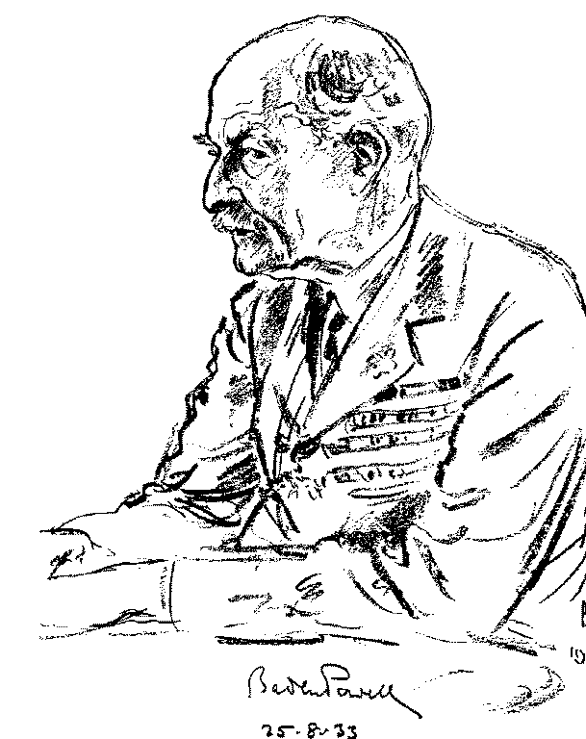
Please send your
ideas and hints to
“The Scout Scope”

SCOUTING@canada.com



